COAL Lab Report – Abdul Hannan Khan

Lab 2:
Task 1: ascii_characters
Code:
.model small
.stack 100h
.data
.code

main proc
mov ah, 2
mov cx, 256
mov dl, 0

print:
int 21h

mov bl, dl
mov dl, 32
int 21h
mov dl, bl

inc dl
dec cx
jnz print

mov ah, 4ch
int 21h
main endp
end main

Output:
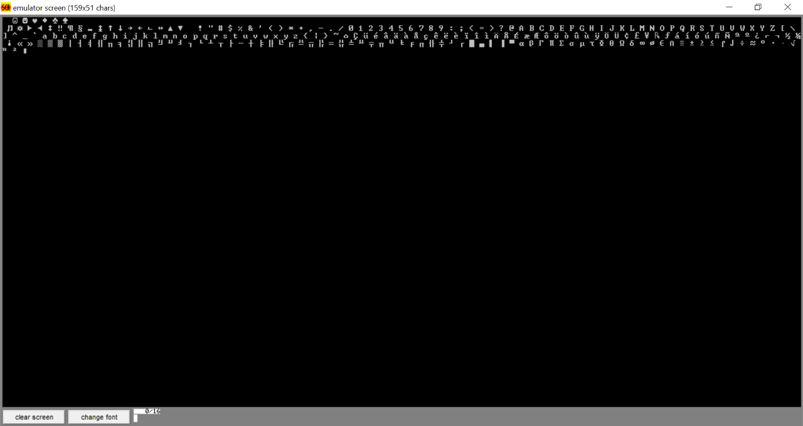

Task 2: arithmetic_operations
Code:
.model small
.stack 100h
.data
msg1 db 'Enter first number: $'
msg2 db 13, 10, 'Enter second number: $'
addMsg db 13, 10, 'Addition: $'
subMsg db 13, 10, 'Subtraction: $'
mulMsg db 13, 10, 'Multiplication: $'
newline db 13, 10, '$'
num1 db ?
num2 db ?
result db ?
.code
main proc
mov ax, @data
mov ds, ax

mov ah, 9
lea dx, msg1
int 21h

mov ah, 1
int 21h
sub al, 30h
mov num1, al

mov ah, 9
lea dx, msg2
int 21h

mov ah, 1
int 21h
sub al, 30h
mov num2, al

mov ah, 9
lea dx, newline
int 21h

call Addition
call Subtraction
call Multiplication

mov ah, 4ch
int 21h
main endp

Addition proc
mov ah, 9
lea dx, addMsg
int 21h

mov al, num1
add al, num2
mov result, al

call DisplayNumber
ret
Addition endp

Subtraction proc
mov ah, 9
lea dx, subMsg
int 21h

mov al, num1
cmp al, num2
jl negative_result

sub al, num2
mov result, al
call DisplayNumber
jmp subtraction_done

negative_result:
mov dl, '-'
mov ah, 2
int 21h

mov al, num2
sub al, num1
mov result, al
call DisplayNumber
subtraction_done:
ret
Subtraction endp

Multiplication proc
mov ah, 9
lea dx, mulMsg
int 21h

mov al, num1
mul num2
mov result, al

call DisplayNumber
ret
Multiplication endp

DisplayNumber proc
mov al, result
mov ah, 0
mov bl, 10
div bl

mov bh, ah

cmp al, 0
je skipFirstDigit
mov dl, al
add dl, 30h
mov ah, 2
int 21h

skipFirstDigit:
mov dl, bh
add dl, 30h
mov ah, 2
int 21h
ret
DisplayNumber endp

end main

Output:
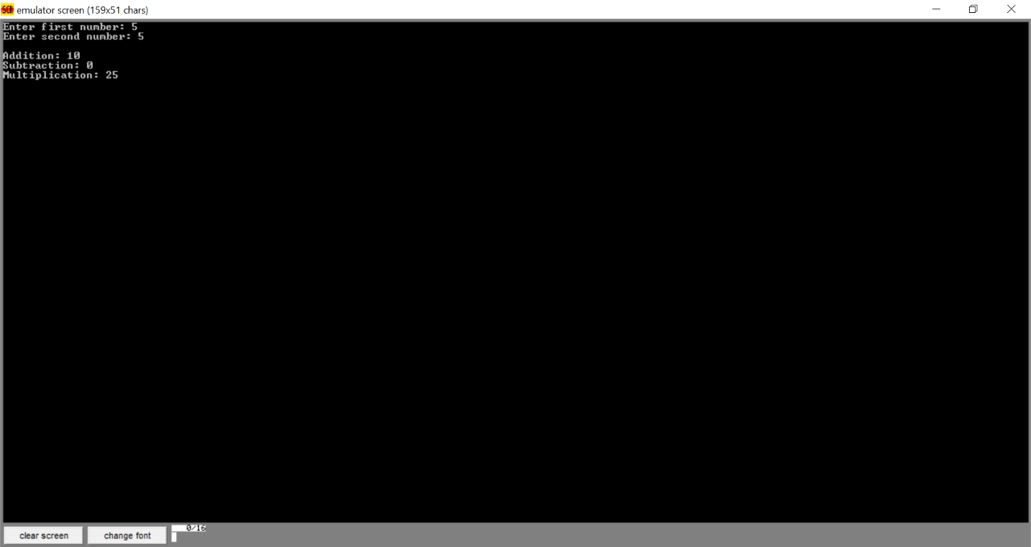

Task 3: multiplication_table
Code:
.model small
.stack 100h
.data
msg db 'Enter a number: $'
newline db 13, 10, '$'
num db ?
.code
main proc
mov ax, @data
mov ds, ax

mov ah, 9
lea dx, msg
int 21h

mov ah, 1
int 21h
sub al, 30h
mov num, al

mov ah, 9
lea dx, newline
int 21h

mov cl, 1

printTable:
mov ah, 2
mov dl, 13
int 21h
mov dl, 10
int 21h

mov dl, num
add dl, 30h
int 21h

mov dl, ' '
int 21h
mov dl, 'x'
int 21h
mov dl, ' '
int 21h

mov dl, cl
add dl, 30h
int 21h

mov dl, ' '
int 21h
mov dl, '='
int 21h
mov dl, ' '
int 21h

mov al, num
mov bl, cl
mul bl

mov bl, 10
div bl

mov bh, ah

cmp al, 0
je skip_tens
mov dl, al
add dl, 30h
mov ah, 2
int 21h

skip_tens:
mov dl, bh
add dl, 30h
mov ah, 2
int 21h

inc cl
cmp cl, 10
jbe printTable

mov ah, 4ch
int 21h
main endp
end main

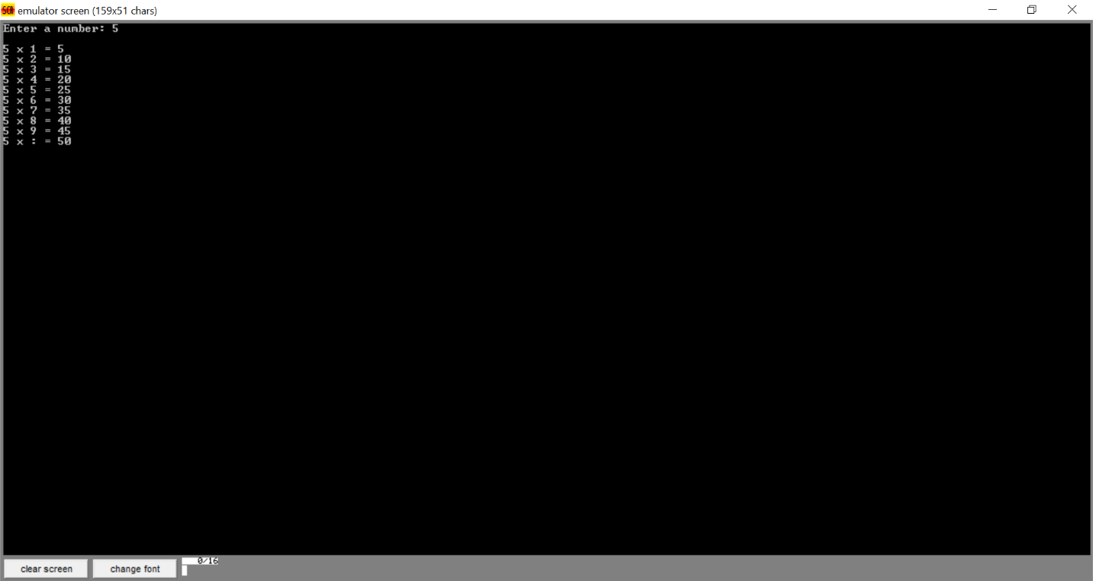
Output:

Lab 3:
Task 1: odd_numbers
Code:
.model small
.stack 100h
.data
newline db 13, 10, '$'
.code
main proc
mov ax, @data
mov ds, ax

mov cx, 1

print_odd:
mov ax, cx
mov bl, 2
div bl

cmp ah, 0
je skip_print

mov ax, cx
mov bl, 10
div bl

mov bh, ah

cmp al, 0
je print_single
mov dl, al
add dl, 30h
mov ah, 2
int 21h

print_single:
mov dl, bh
add dl, 30h
mov ah, 2
int 21h

mov dl, ' '
int 21h

skip_print:
inc cx
cmp cx, 100
jle print_odd

mov ah, 9
lea dx, newline
int 21h

mov ah, 4ch
int 21h
main endp
end main

Output:
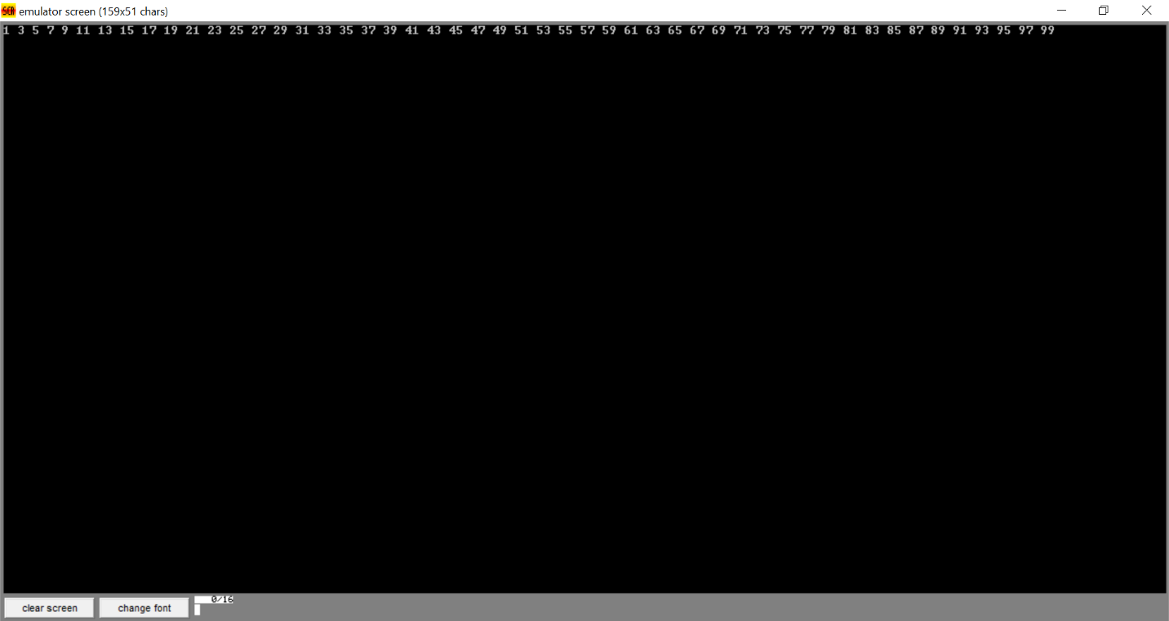

Task 2: condition_loop
Code:
.model small
.stack 100h
.data
msg1 db 'Enter x: $'
msg2 db 13, 10, 'Enter y: $'
newline db 13, 10, '$'
zero db '0$'
x db ?
y db ?
.code
main proc
mov ax, @data
mov ds, ax

mov ah, 9
lea dx, msg1
int 21h

mov ah, 1
int 21h
sub al, 30h
mov x, al

mov ah, 9
lea dx, msg2
int 21h

mov ah, 1
int 21h
sub al, 30h
mov y, al

mov ah, 9
lea dx, newline
int 21h

mov al, x
cmp al, 4
jg else_part

mov al, y
cmp al, 9
jg else_part

mov cl, 0

loop_start:
cmp cl, x
jge end_loop

mov dl, x
add dl, 30h
mov ah, 2
int 21h

inc cl
jmp loop_start

else_part:
mov ah, 9
lea dx, zero
int 21h

end_loop:
mov ah, 9
lea dx, newline
int 21h

mov ah, 4ch
int 21h
main endp
end main

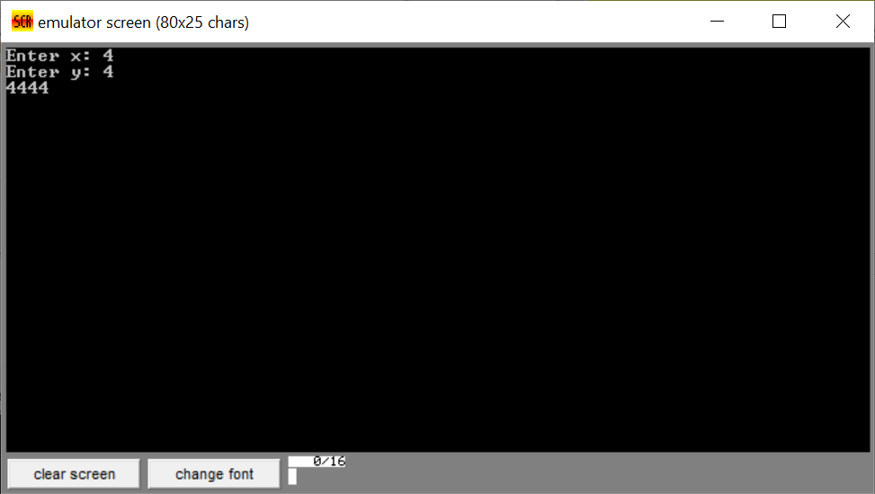
Output:

Task 3: largest_number
Code:
.model small
.stack 100h
.data
msg1 db 'Enter x: $'
msg2 db 13, 10, 'Enter y: $'
newline db 13, 10, '$'
zero db '0$'
x db ?
y db ?
.code
main proc
mov ax, @data
mov ds, ax

mov ah, 9
lea dx, msg1
int 21h

mov ah, 1
int 21h
sub al, 30h
mov x, al

mov ah, 9
lea dx, msg2
int 21h

mov ah, 1
int 21h
sub al, 30h
mov y, al

mov ah, 9
lea dx, newline
int 21h

mov al, x
cmp al, 4
jg else_part

mov al, y
cmp al, 9
jg else_part

mov cl, 0

loop_start:
cmp cl, x
jge end_loop

mov dl, x
add dl, 30h
mov ah, 2
int 21h

inc cl
jmp loop_start

else_part:
mov ah, 9
lea dx, zero
int 21h

end_loop:
mov ah, 9
lea dx, newline
int 21h

mov ah, 4ch
int 21h
main endp
end main

Output:
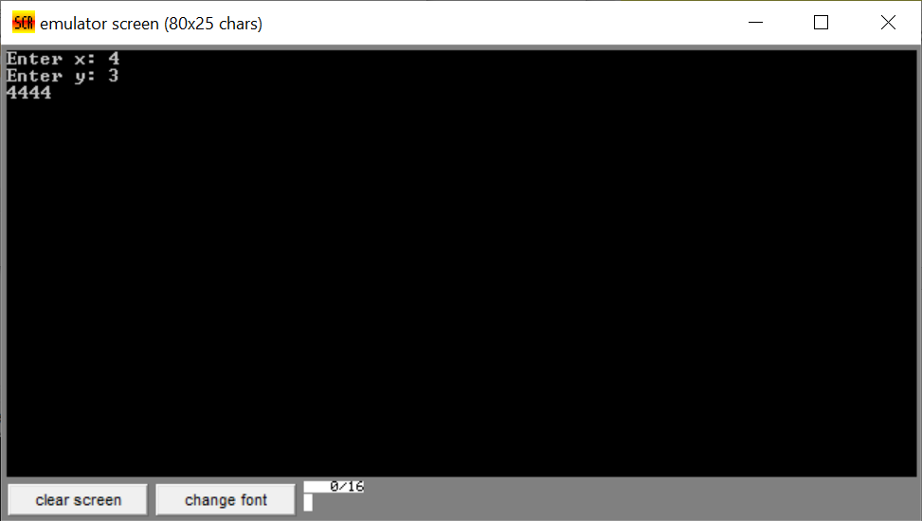

Lab 4:
Task 1: addition
Code:
.model small
.stack 100h
.data
msg1 db 'Enter first number: $'
msg2 db 13, 10, 'Enter second number: $'
resultMsg db 13, 10, 'Addition Result: $'
newline db 13, 10, '$'
num1 db ?
num2 db ?
result db ?
.code
main proc
mov ax, @data
mov ds, ax

mov ah, 9
lea dx, msg1
int 21h

mov ah, 1
int 21h
sub al, 30h
mov num1, al

mov ah, 9
lea dx, msg2
int 21h

mov ah, 1
int 21h
sub al, 30h
mov num2, al

mov ah, 9
lea dx, resultMsg
int 21h

mov al, num1
add al, num2
mov result, al

mov al, result
mov ah, 0
mov bl, 10
div bl

mov bh, ah

cmp al, 0
je single_digit

mov dl, al
add dl, 30h
mov ah, 2
int 21h

single_digit:
mov dl, bh
add dl, 30h
mov ah, 2
int 21h

mov ah, 9
lea dx, newline
int 21h

mov ah, 4ch
int 21h
main endp
end main

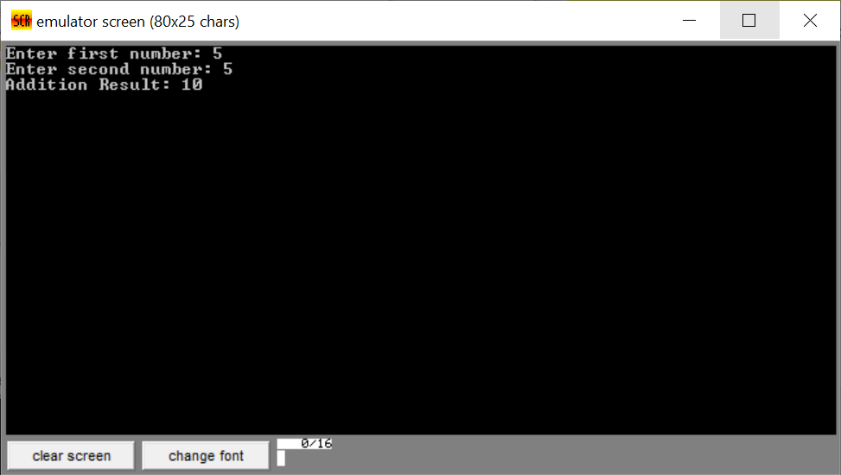
Output:

Task 2: multiplication
Code:
.model small
.stack 100h
.data
msg1 db 'Enter first number: $'
msg2 db 13, 10, 'Enter second number: $'
resultMsg db 13, 10, 'Multiplication Result: $'
newline db 13, 10, '$'
num1 db ?
num2 db ?
result db ?
.code
main proc
mov ax, @data
mov ds, ax

mov ah, 9
lea dx, msg1
int 21h

mov ah, 1
int 21h
sub al, 30h
mov num1, al

mov ah, 9
lea dx, msg2
int 21h

mov ah, 1
int 21h
sub al, 30h
mov num2, al

mov ah, 9
lea dx, resultMsg
int 21h

mov al, num1
mul num2
mov result, al

mov al, result
mov ah, 0
mov bl, 10
div bl

mov bh, ah

cmp al, 0
je single_digit

mov dl, al
add dl, 30h
mov ah, 2
int 21h

single_digit:
mov dl, bh
add dl, 30h
mov ah, 2
int 21h

mov ah, 9
lea dx, newline
int 21h

mov ah, 4ch
int 21h
main endp
end main

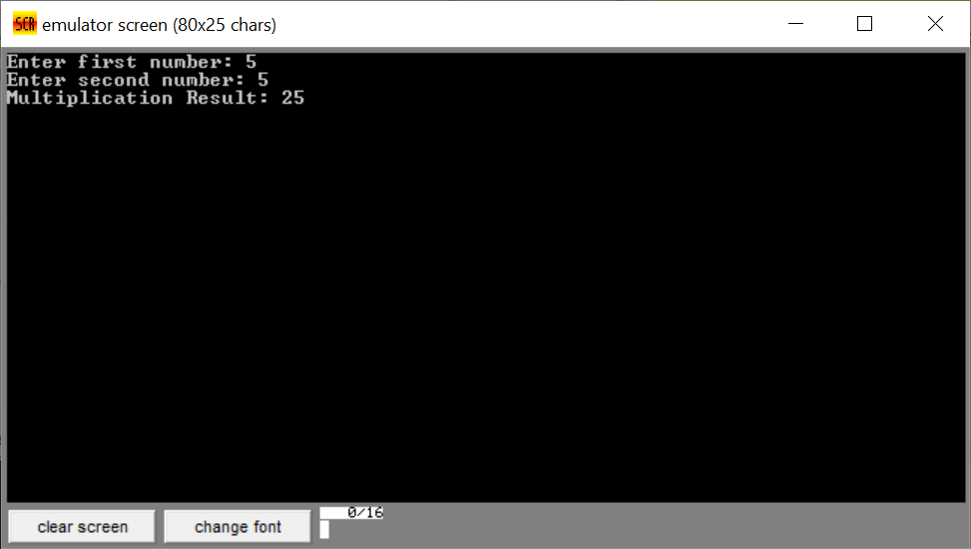
Output:

Lab 6:
Task 1: case_converter
Code:
.model small
.stack 100h
.data
msg db 'MASTER$'
.code
main proc
mov ax, @data
mov ds, ax
lea si, msg
mov cx, 6

label:
mov al, [si]
OR al, 00100000b
mov dl, al
mov ah, 2
int 21h
inc si
loop label

mov ah, 4ch
int 21h
main endp
end main

Output:
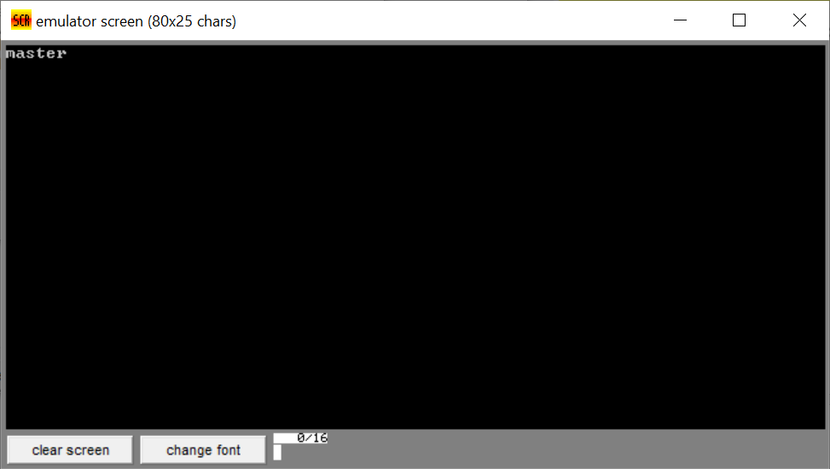

Lab 7:
Task 1: extract_month_bits
Code:
.model small
.stack 100h
.data
month db ?
.code
main proc
mov ax, @data
mov ds, ax

mov dx, 266Ah
mov ax, dx
shr ax, 5
and al, 00001111b
mov month, al

add month, al

add month, 30h
mov dl, month
mov ah, 2
int 21h

mov ah, 4ch
int 21h
main endp
end main

Output:
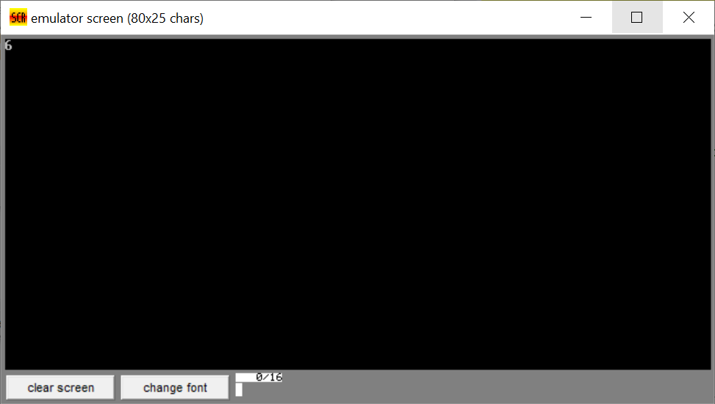

Task 2: month_extracter
Code:
.model smapp
.stack 100h
.data
date dw 2A2Ah
month db ?
.code
main proc
mov ax, @data
mov ds, ax

mov ax, date
and ax, 01E0h
mov cl, 5
shr ax, cl
mov month, al

add month, 30h
mov dl, month
mov ah, 2
int 21h

mov ah, 4ch
int 21h
main endp
end main

Output:
